Theoretical background
Machine Learning
Tom Mitchell states machine learning as “A computer program is said to learn from experience and from some tasks and some performance on, as measured by, improves with experience”. Machine Learning is combination of correlations and relationships, most machine learning algorithms in existence are concerned with finding and/or exploiting relationship between datasets. Once Machine Learning Algorithms can pinpoint on certain correlations, the model can either use these relationships to predict future observations or generalize the data to reveal interesting patterns. In Machine Learning there are various types of algorithms such as Regression, Linear Regression, Logistic Regression, Naive Bayes Classifier, Bayes theorem, KNN (K-Nearest Neighbor Classifier), Decision Tress, Entropy, ID3, SVM (Support Vector Machines), K-means Algorithm, Random Forest and etc.,
The name machine learning was coined in 1959 by Arthur Samuel. Machine learning explores the study and construction of algorithms that can learn from and make predictions on data Machine learning is closely related to (and often overlaps with) computational statistics, which also focuses on prediction-making through the use of computers. It has strong ties to mathematical optimization, which delivers methods, theory and application domains to the field. Machine learning is sometimes conflated with data mining, where the latter subfield focuses more on exploratory data analysis and is known as unsupervised learning.
Within the field of data analytics, machine learning is a method used to devise complex models and algorithms that lend themselves to prediction; in commercial use, this is known as predictive analytics. These analytical models allow researchers, data scientists, engineers, and analysts to "produce reliable, repeatable decisions and results" and uncover "hidden insights" through learning from historical relationships and trends in the data.

Machine learning tasks Machine learning tasks are typically classified into several broad categories:
Supervised learning: The computer is presented with example inputs and their desired outputs, given by a "teacher", and the goal is to learn a general rule that maps inputs to outputs. As special cases, the input signal can be only partially available, or restricted to special feedback.
Semi-supervised learning: The computer is given only an incomplete training signal: a training set with some (often many) of the target outputs missing.
Active learning: The computer can only obtain training labels for a limited set of instances (based on a budget), and also has to optimize its choice of objects to acquire labels for. When used interactively, these can be presented to the user for labelling.
Unsupervised learning: No labels are given to the learning algorithm, leaving it on its own to find structure in its input. Unsupervised learning can be a goal in itself (discovering hidden patterns in data) or a means towards an end (feature learning).
Reinforcement learning: Data (in form of rewards and punishments) are given only as feedback to the program's actions in a dynamic environment, such as driving a vehicle or playing a game against an opponent.

Benefits of Machine Learning:
- Achieve economies of scale – increase volume output or productivity with fewer people. Your cost per unit, project or product plummets.
- Reduce spending on technology infrastructure. Maintain easy access to your information with minimal upfront spending. Pay as you go (weekly, quarterly or yearly), based on demand.
- Globalize your workforce on the cheap. People worldwide can access the cloud, provided they have an Internet connection.
- Streamline processes. Get more work done in less time with less people.
- Reduce capital costs. There’s no need to spend big money on hardware, software or licensing fees.
- Improve accessibility. You have access anytime, anywhere, making your life so much easier!
- Monitor projects more effectively. Stay within budget and ahead of completion cycle times.
- Less personnel training is needed. It takes fewer people to do more work on a cloud, with a minimal learning curve on hardware and software issues.
- Minimize licensing new software. Stretch and grow without the need to buy expensive software licenses or programs.
- Improve flexibility. You can change direction without serious “people” or “financial” issues at stake.
Advantages:
- Price: Pay for only the resources used.
- Security: Cloud instances are isolated in the network from other instances for improved security.
- Performance: Instances can be added instantly for improved performance. Clients have access to the total resources of the Cloud’s core hardware.
- Scalability: Auto-deploy cloud instances when needed.
- Uptime: Uses multiple servers for maximum redundancies. In case of server failure, instances can be automatically created on another server.
- Control: Able to login from any location. Server snapshot and a software library lets you deploy custom instances.
- Traffic: Deals with spike in traffic with quick deployment of additional instances to handle the load.

3.2 Introduction to PYTHON
Python Technology
Python technology is both a programming language and a platform.
The python Programming Language
THE PYTHON PROGRAMMING LANGUAGE IS A HIGH-LEVEL LANGUAGE THAT CAN BE CHARACTERIZED BY ALL OF THE FOLLOWING BUZZWORDS:

    - Simple
    - Architecture neutral
    - Object oriented
    - Portable
    - Distributed
    - High performance
    - Interpreted
    - Multithreaded
    - Robust
    - Dynamic
    - Secure

With most programming languages, you either compile or interpret a program so that you can run it on your computer. The Python programming language is unusual in that a program is both compiled and interpreted. With the compiler, first you translate a program into an intermediate language called Python byte codes —the platform-independent codes interpreted by the interpreter on the Python platform. The interpreter parses and runs each Python byte code instruction on the computer. Compilation happens just once; interpretation occurs each time the program is executed. The following figure illustrates how this works.
FEATURES OF MACHINE LEARNING
• It is nothing but automating the Automation.
• Getting computers to program themselves.
• Writing Software is bottleneck.
• Machine leaning models involves machines learning from data without the help of humans or any kind of human intervention.
• Machine Learning is the science of making of making the computers learn and act like humans by feeding data and information without being explicitly programmed.

• Machine Learning is totally different from traditionally programming, here data and output is given to the computer and in return it gives us the program which provides solution to the various problems. Below is the figure.
Traditional Programming vs Machine Learning
• Machine Learning is a combination of Algorithms, Datasets, and Programs.
• There are Many Algorithms in Machine Learning through which we will provide us the exact solution in predicting the disease of the patients.
• How Does Machine Learning Works?
• Solution to the above question is Machine learning works by taking in data, finding relationships within that data and then giving the output.
Machine Learning Model

• There are various applications in which machine learning is implemented such as Web search, computing biology, finance, e-commerce, space exploration, robotics, social networks, debugging and much more.
• There are 3 types of machine learning supervised, unsupervised, and reinforcement.
BENEFITS OF PYTHON
• Presence of Third-Party Modules
• Extensive Support Libraries
• Open Source and Community Development
• Learning Ease and Support Available
• User-friendly Data Structures
• Productivity and Speed
• Highly Extensible and Easily Readable Language.

Python
Python is high level language and it is also integrated version of the program. Python is an object-oriented approach and its main aim to help programmers to write the code clearly, logical code for small and large scale of project.
Pytrhon is dynamically typed and garbage collected it also support multiple programming and it is both procedure and object oriented and also functional programming. And structural programming also supported. It has many built in function it also supports filter, map and reduce function. All the machine learning algorithm and the libraries are being supported by the python programming language. Python also support list, dict, sets and other generators. Python code can be run in different platform such as anaconda, PyCharm etc.
The main goal of this programing language is as follows:

• Python is simple, object-oriented programming language.
• The language and implementation should provide support for software engineering principles such as strong type library preset for different machine learning algorithm, and all other algorithm in simple manner.
• Coding will be smooth in python and the data analysis can be easily done in python.
This is so much so to the point where we now have modules and APIs at our disposal, and you can engage in machine learning very easily without almost any knowledge at all of how it works. With the defaults from Scikit-learn, you can get 90-95% accuracy on many tasks right out of the gate. Machine learning is a lot like a car, you do not need to know much about how it works in order to get an incredible amount of utility from it.
Despite the apparent age and maturity of machine learning, I would say there's no better time than now to learn it, since you can actually use it. Machines are quite powerful, the one you are working on can probably do most of this series quickly. Data is also very plentiful lately.

Anaconda
Anaconda is free and open-source distribution of the Python and R programming languages for scientific computing (data science, machine Learning applications, Large- scale data processing, predictive analytics, etc.), that aims to simplify package management and deployment. It is developed and maintained by Anaconda, Inc. The distribution incudes data-science packages suitable for Windows, Linux, and macOS. Packaged versions are required and are managed by the package management system anaconda. This package manager was spun out as a separate open-source package as it ended up being useful on its own and for other things than Python. There is also a small, bootstrap version of Anaconda called Miniconda, which includes only conda, Python, the packages they depends on, and a small number of other packages.
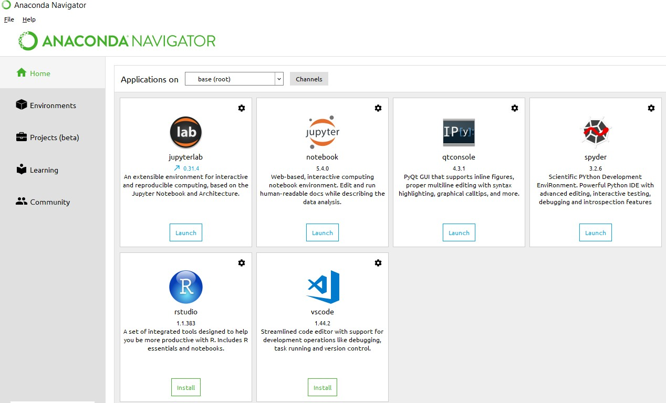
Anaconda Console

Jupyter notebook
Jupiter Notebook or so called IPython Notebook is an interactive web based computational mean for starting with Jupiter Notebook documents. The term notebook itself is a huge entity to represent the integration with different entity sets. JSON is the main document form from the same for the execution which follows the brief on the schema and the input and output means. It has high integration with several language set and has various flexibilities with the choices. The extension used for the same is “.ipynb” which runs in this platform. It’s an open-source software package with interactive communication means. It has it’s open standards for the same. It’s an open community best for budding programmers . The flexibility of the same is phenomenon and splendidly done the configuration and integration of the same is simplest and easy on hold so that no prior distortion is generated and the efficiency of the same is measured through out any system of choice.
It’s the best software sets that been used across cross for designing and developing of the products and support wide help support. Not only to that, it provides scalability in the code and the deployment of the same. Various Language can be changed and the project can be undertaken on the same. The created notebook files can be shared and stored in various means for further utilization. It supports cultivated and interactive output sets. Easily crossed over for graphing, plotting and visualizing of the elements. Data Integration of the same is to it’s best. The integration of big data and it can process chunks of values in an approx. time which gives a better performance and the higher computational means. Various works on data like cleaning, cleansing, transforming modeling and visualizing can be done by the same

Machine learning is the ability that gives the computer to learn without being explicitly programmed. There are two types of machine learning:
Supervised Learning: supervised learning is the learning of the labelled data. It is the types of machine learning that maps the input and output based on the examples input-output pairs. In supervised learning each training data having pairs of input and desired outputs values. Supervised learning algorithm analyzes the training data and produces a function which can be used for mapping of new data.

Fig 2.1 Supervised Learning The output to solve the supervised learning algorithm are as:
• Determine the types of data, before doing anything else the user should understand which types of data set is to be used for training the data.
• Gathered the training data sets either in form of human experts or from measurements.

• Determine the feature of inputs from the learned data and depends on the inputs it changed into feature vector; number of features should not be large but should contains enough information to accurately predict the outputs.
• Check the learned function and the learned algorithm for example we use support vector machines or decisions tree.
• Complete the design and run the trained data sets.
• Analyzed the output and verify the data sets to get the accurate outputs.

Unsupervised Learning:
Unsupervised learning is a type of machine learning that helps in finding the previously unknown patterns in the data set without any known labels. It is known as self- organization and allows modelling probability densities of given inputs.

Fig 2.2 unsupervised Learning Some of the algorithm used in unsupervised learning are:
• Clustering
• Anomaly detection
• Neural networks
• Approach for learning latent variable models
• Non labelled data

Semi Supervised Machine Learning algorithm: It’s like the middle man which have some labeled data and some unlabeled which can be prosed by the both the structured and unsupervised learning.
The algorithms have been compared based upon the parameters: Size of the dataset and Number of technical indicators used. Accuracy and F-measure values have been computed for each algorithm. Long term model has been used to compute the accuracy and F-measure.
Reinforcement Learning: This type of learning is used to reinforce or strengthen the network based on critic information. That is, a network being trained under reinforcement learning, receives some feedback from the environment. However, the feedback is evaluative and not instructive as in the case of supervised learning. Based on this feedback, the network performs the adjustments of the weights to obtain better critic information in future.
This learning process is similar to supervised learning but we might have very less information. The following figure gives the block diagram of reinforcement learning:

